

Jonas, Donato, Pedro, Loan

Content

Content 2

Key Activities 3

Key Partners 3

Key Resources 3

Value Proposition 3

Business Case 4

Use Case 4

Personas 4

Scenario 4

Use Case 1 4

Scenario 1 4

Use Case 2 5

Scenario 1 5

Actors 5

Stakeholders 5

Domain Model 5

Object Model 6

System Sequence Diagram 7

• Use Case 1 7

• Use Case 2 7

Class Diagram 8

Purpose

Our Product Owners currently uses a website-based subscription service to manage their daily business activities. It is quite costly as the company must pay for the subscription every month. The company has had a great growth rate during the past years and would like to expand its it system, thus they can save IT cost in the long term. Our mission is to help the company to develop a console app which can be used to manage employees’ daily working schedules. This preliminary project helps our customers to have an overview concept about the actual app, which we hope to develop for them in the future

Business Model

# Key Activities

CR Window Cleaning & Cleaning Service/CR Vinduespolering & Rengøring (CR) was founded in 1998 by Claus Rasmussen. He started his business quite simple with by running around and cleaning windows for its customers in Odense and Fyn.

The company kept growing steadily for many years. In 2009, CR grew to a certain size that Claus decided to employ Ole Lauritsen as a window cleaner. Initially Claus and Ole drove around together, but after a short period he had purchased another car thus both has more time to service all the new customers in a satisfactory manner.

Today Ole Lauritsen is the operation manager and he is responsible for the daily operation and at the same time has an overview of the company's vehicles and personnel consisting of 28 window cleaners and cleaners, and office staff

CR has almost 20 years of experience in cleaning industry. They offer window cleaning services as well as normal cleaning services for businesses and individuals, for commercial and private locations.

The main activities are Window cleaning for business and individual. CR Window Cleaning & Cleaning performs window cleaning and cleaning of window frames in all types of building, both inside and out. For both private and business from the branch situated in Fredericia, and for customers in Kolding, Vejle, Middelfart and Fredericia.

# Key Partners

Employee: the company relies on the employee's turnover.  
Customers: the company has customers in Odense as well as in Kolding, Fredericia and Middelfart. Their customers are private economic operators, professional associations, banks, municipal and private institutions, housing associations, etc.

# Key Resources

* Employees (28)
* Cleaning equipment
* Vehicles
* IT System
* Knowledge of the market

# Value Proposition

* Skilled and competent window washers with many years of experience
* Customize service: flexible times based on the specific customer’s needs
* Cheap window cleaning service: the head office is in Odense, but the window cleaners are assigned cleaning tasks, which are closed to their resident locations. In other words, the company would save cost on transportation, thus they can offer a very affordable window cleaning service to their customers.
* Environmentally friendly products: detergents that are inexpensive, environmentally approved and have ecolabels - Svane logo
* Coverage a big area: all of Funen and much of Jutland
* Hight quality service: efficient cleaning by the appropriate use of machines and precision
* Maintain good relationship and keep regular contacts with their customers
* Customer satisfaction is continuing improvement are company's key strategies

# Business Case

We help the company to make a customer schedule management system to better manage customer’s appointments and more convenient for their employees to use the software. Thus, they can improve their service quality and customer’s satisfaction

# Use Case

* Use Case 1: Managers - as an administrator - can add or update customer information, date and time and assigns tasks for his employees on the system, he can also edit the input information
* Use Case 2: Employee - as a user - can log in the system daily and check their working schedule. However, the employees cannot change the information in the system

# Personas

We’ve decided to focus our scenario’s around the 3 main personas found in the company.

* Users who does not know much about computer and technology
  + can use technology such as smart-phones ect.
  + Relies on tech support for all issues
  + Prefers old methods such as paper slips and notes
* Users who are tech savvy and enjoy using computer
  + Contacts tech support for major issues only
  + Enjoys using online / tech based organization tools
* Users who does not speak Danish very well
  + See less tech savvy persona

# Scenario

## Use Case 1

### Scenario 1

* Administrators log in the system with an username (email) and password, the system checks authorization and verify whether the input information is correct. If the input information is correct, the system allows the administrator to log in. The administrator now can add \***customer information** (customer name, customer address, customer postal code, customer city), \***working schedule** (starting time, closing time) and \***assign tasks** (employees name) to the users. The system updates and displays the input information on the screen

Scenario 2

* Administrators log in the system with an incorrect username (email) and password, the system fails to verify the authorization and denies access to the system. The administrators can try to log in the system again. If the username and password are correct, the system allows the administrators to access the system and update \***customer information,** \***working schedule** and\***assign tasks** (employees name) to the users. If the administrators put incorrect username or password 3 times, the system will block the access for 10 minutes

## Use Case 2

### Scenario 1

* Users log in the system with an username (email) and password, the system checks authorization and verify whether the input information is correct. If the input information is correct, the system allows the users to log in the system and see information on the screen.

Scenario 2

* Users log in the system with an incorrect username (email) and password, the system fails to verify the authorization and deny access to the system. Users can try to log in again. The system will allow them to access the system once they input the correct username and password

# Actors

* Users
  + Employees
* Admins
  + Office Staff
  + Managers

# Stakeholders

Ole, and his co-partner (50/50 ??)

And all the employees themselves.

# Domain Model



# Object Model



# System Sequence Diagram

# Use Case 1

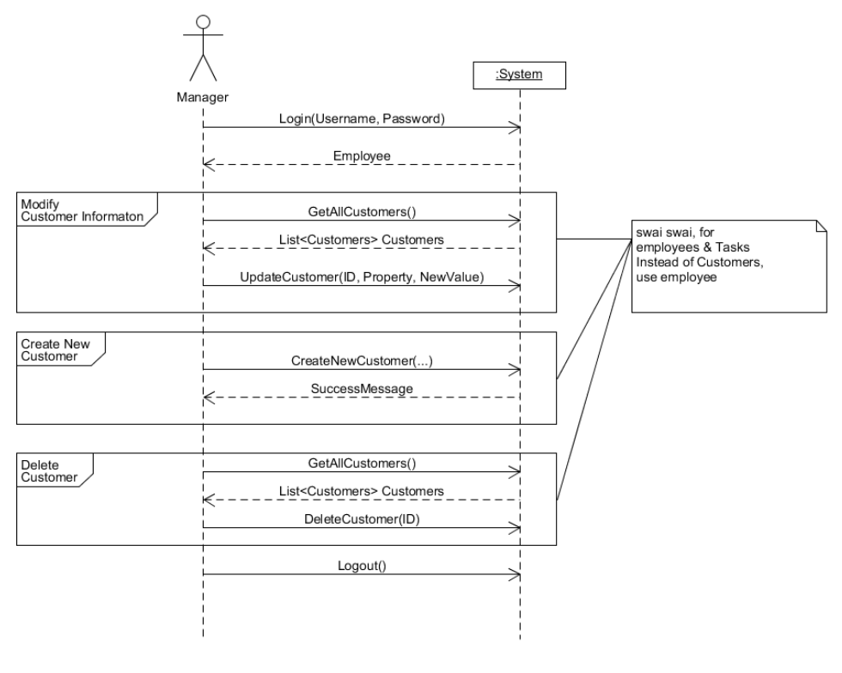

# System Operation Contract

|  |  |
| --- | --- |
| **Operation:** | Login(username, password) |
| **Cross References:** | Use case 1, SSD – Manager, SSD – Employee |
| **Preconditions:** | User not already logged in |
| **Postconditions:** | Employee instance created (instance creation) |

|  |  |
| --- | --- |
| **Operation:** | GetAllEmployee() |
| **Cross References:** | UC1, SSD Manager |
| **Preconditions:** | Logged in as a manager |
| **Postconditions:** | List of all Employee |

|  |  |
| --- | --- |
| **Operation:** | UpdateEmployee(id, propery, newvalue) |
| **Cross References:** | SSD Manager |
| **Preconditions:** | Employee with ID Exists  Logged in as a manager |
| **Postconditions:** | Employee Information changed & saved |

|  |  |
| --- | --- |
| **Operation:** | CreateNewEmployee(..) |
| **Cross References:** | SSD Manager |
| **Preconditions:** | Logged in as a manager |
| **Postconditions:** | New Empoyee object (instantiation)  Saved |

|  |  |
| --- | --- |
| **Operation:** | DeleteEmployee(ID) |
| **Cross References:** | SSD Manager |
| **Preconditions:** | Logged in as a manager  Employee of ID exists |
| **Postconditions:** | Employee of ID no longer exists |

# System Sequence Diagram

# Use Case 2



# Class Diagram



# Sequence Diagrams

## Create New Customer



## Update Customer



## LoginC:\Users\jlaur\AppData\Local\Microsoft\Windows\INetCacheContent.Word\SD - UpdateCustomer.png

**PROJECT LOG**

* **PRESPRINT Wk43**

**Wk43/ Day1**

Discuss Working Methods & Tools. We use Trello as a co-working environment, Scrum Management, Materials Storage and Github for Code Sharing

**Wk43/ Day 2**

Make a group contract about general working rules and team members' roles

**Wk43/ Day 3 & 4**

Outline main points of Business Model and Business Analysis based on the company website

**Wk43/ Day 5 & 6**

Pre-draw Domain Model & Object Model based on assumption information from the company website

* **SPRINT 1 Wk44 – Wk45**

**Wk44/ Day 1**

Prepared interview questions for the Project Owner and had a meeting with him

**Wk44/ Day 2**

Business Model & Business Analysis

User Stories, Roles & Scenarios

**Wk44/ Day 3**

Product Backlog & Sprint Backlog

**Wk44/ Day 4**

Update Object Model & Domain Model based on the information from the Product Owner

**Wk44/ Day 5**

System Sequence Diagram

Set up the Getting Real Project in Visual Studio

**Wk45/ Day 1**

Programming Class & Business Lecture - No Group Project

**Wk45/ Day 2**

Class Diagram

**Wk45/ Day 3**

Outline Criteria for feedback

**Wk45/ Day 4**

Task 14: Update Artefacts: Domain Model, Object Model, Class Diagram. Task 15: Update Report

**Wk45/ Day 5**

Task 3: Sequence Diagram. Task 15: Update Report

* **SPRINT 2 Wk46 – Wk47**

**Wk46/ Day 1**

Learning Database – No Group Meeting

**Wk46/ Day 2**

Update System Sequence Diagram

**Wk46/ Day 3**

International Student Event – No Group Meeting

**Wk46/ Day 4**

Update Sequence Diagram for Employee Login System

Create Codes for Employee Login System

Test Employee Login

**Wk46/ Day 5**

No Group Meeting

**Wk47/ Day 1:**

Learning Database: No Group Meeting

**Wk47/ Day 2:**

Prepare Project Presentation

**Wk47/ Day 3:**

Write Codes: Employee Class

Testing Codes: Employee Class: Add, Update, Delete

System Operation Contracts for Employee

**Wk47/ Day 4:**

Write Codes: Customer Class

Testing Codes: Customer Class: Add, Update, Delete